Park Commissioners Agenda 06/06/2023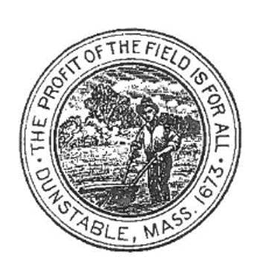 PARK COMMISSIONERS MEETING MINUTES | OFFICE OF THE PARK COMMISSION  TOWN HALL, 511 MAIN STREET  DUNSTABLE, MA 01827-1313  978-649-4514 x224  PARK COMMISSIONERS MEETING MINUTES
A Joint Meeting of the Park Commissioners and Recreation Commissioners.

Meeting Date: Tuesday, June 13, 2023, at 6:30 PM

Meeting in person at the Dunstable Town Hall, 511 Main Street, Dunstable, MA.

Note: The listings of matters are those reasonably anticipated by the Commissioners which may be discussed at the meeting. Not all items listed may in fact be discussed and other items not listed may also be brought up for discussion to the extent permitted by law.

SCHEDULED AGENDA ITEMS
Topics the Chair reasonably anticipates will or could be discussed.
Scheduled Agenda Items: Joint Topics
- Review and approval of meeting minutes: May 9 and May 22, 2023
- 350th Anniversary Committee attending to discuss event at Larter.
- Tennis courts- update
- Update on mulch 11 trees at Larter and Swallow union and install 1 yard of stone dust in Softball dugout.
- Discuss new landscape contract, well and irrigation and ball field grooming.
- Shed repair update

7. Recreations Topics
- Field Use Applications
- Babe Ruth Field rehab

8. Parks Topics
- FY23 Budget and Project Priorities. Review
- Well and Irrigation update

9. New Business, As
MEETING MINUTES

Attending the meeting for the Park Commission and a quorum being present: Tiffany Naughton and Jean Phelan
Attending for Recreation Commission and a quorum being present- Tiffany Naughton, Jeff Hastings, Charlie Lippman and Brian Locapo.

- Meeting came to order at 6:30 pm. Meeting minutes from the previous joint committee meeting of May 22, 2023, were reviewed, and approved by those present. Meeting minutes will be posted to the Town website.
- 350th committee member Jon Crandall, Kathy Sniezek and Erica Flynn attended meeting to discuss 350th grand finale hometown hoedown scheduled for Oct 14 and requested the use of Larter field for the event. Parks and Recs voted to approve.
- Update on landscape work completed.
- Estimates for final 2023 budget work discussed and voted on to approve.
        - Corbett irrigation work for Larter field.
        - Organic Fertilizer, charge 3 amendments and Calcitic lime application for Larter and Organic Fertilizer for town common, Town Hall and Police station.

- The Meeting was adjourned at 7:43

Respectfully Submitted,
Jean Phelan
Park Commissioner

.

