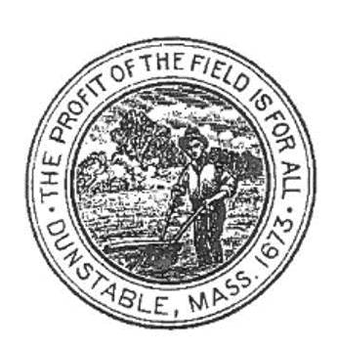 | OFFICE OF THE PARK COMMISSION  TOWN HALL, 511 MAIN STREET  DUNSTABLE, MA 01827-1313  978-649-4514 x224
PARK COMMISSION MEETING MINUTES
Approved: Draft
Meeting Date: March 14, 2023

Scheduled Agenda Items: Joint Topics
- Review and approval of meeting minutes: Feb 14, 2023
- Ice rink update
- Larter Shed repair.
- Tennis courts

- Recreations Topics
  - Field Use Applications
  - Review of new Portable Toilet quote.

- Parks Topics
  - FY23/ 2024 Budget and Project Priorities-
  - 2024 Budget requests- Update if any
  - Update on 2024 Capital requests and CPA Applications
- New Business, As Needed
- Tentative Next meeting April 11, 2023

Meeting Minutes.

1.This was a joint meeting of the Park Commissioners and the Recreation Commissioners and was conducted in the Town Hall.

      - Attending the meeting for the Park Commission and a quorum being present: Tiffany Naughton, and Jean Phelan.

      - Attending the meeting for the Recreation Commission and a quorum being present: Dawn Dorr, Tiffany Naughton, Jeffery Hastings, Brian Locapo and Charlie Lippman.

- The meeting came to order at 6:42 PM. Meeting minutes from the previous joint committee meeting of Feb 14, 2023, were reviewed, and approved by those present. Meeting minutes will be posted to the Town website.

- Joint topics discussed
- Ice Rink- Discussion of selling Rink if possible
- Later Sheds repair - Voted to contribute funds from Rec account for back structure repair and new door. Remaining funding amount needed to be requested from CPA
- Voted to proceed with moving the proposed new tennis court location to Larter Field. Will need to be approved at CPC and Town Meeting. Application to be submitted to CPC.
Dawn Dorr volunteered to contact Tennis Court company to get information.

- Recreation Topics.
  - Discussion of Field use applications received so far. Application received from Groton Dunstable Youth Softball League. Application is for field at Larter from 4/1-8/19. Boards requesting key be left at shed for grooming machine. Approved.
  - Quote received from Instant Portable Toilets for portable toilet use in town. Discussion of past history with this company regarding billing concerns and cleaning frequency. Decision to remain with current company of Powerhouse due to satisfaction with services received.

- Park Topics.
- Remaining funds for 2023 budget reviewed and project priorities discussed. See additional list attached. Discussion of Larter Wells and Irrigation a priority.
- General discussion of funding types and qualifications for etc.
- The meeting was adjourned at 8:00 PM.

Respectfully Submitted,
Jean Phelan
Park Commissioner

Dunstable Parks and Recs to do list 2022/23 Budget. End date June 30, 2023
1- Well Repair and service
2- Irrigation repair as needed
3- Larter Recs Shed repair – New garage door and misc. repair
5- Babe Ruth Field Rehabbed
6- Stone dust added to softball dugout
7- Calcitic Lime applied to Larter field
8- Organic Fertilizer applied to Larter field. Promote seed germination, soil structure and health
9- Playground mulch- rake mounds into holes- Swallow Union
11- Mulch 3 trees at Swallow union
12- Plow damage cleanup at Larter Track

Dunstable Parks and Recs to do list 2023/24 Budget. July1 to June 30, 2024
1- Finish remaining work needed on Larter sheds
2- Monthly Power rake of Ball fields for July and august
3- Sink holes repaired in Larter parking lot and Larter soccer field
4- Cracks filled in Basketball court at larter
5- Beach sand applied to Larter Volleyball courts
6- Late season organic fertilizer applied to larter field

